Background: This draft agenda has been created by the VSEA Communications Committee as a tool for Chapter Presidents to organize Chapter meetings. Chapter Presidents are encouraged to use these agendas but may create their own. New agendas will be shared by the Communications Committee each quarter with topical agenda items based on time of year and union happenings.
Instructions:
- Agendas will be shared two weeks prior to each quarterly Council meeting so that Chapter Presidents can organize Chapter meetings two weeks after each quarterly Council meeting.
  - See Council meeting schedule.
  - Recent/future meetings: 9/18/26; 12/11/26
- If using this agenda template, Presidents should at minimum update all highlighted fields.
- Presidents may add or remove agenda items.
- Chapter meetings are governed by Robert’s Rules of Order. See Robert’s rules simplified.
- Login access to the VSEA website is strongly encouraged to access key informational documents.
Delete the background and instructions above prior to sharing with members.

[Location] Chapter Meeting

Agenda
Date | [10/DD/2026]
Time | [Start time] – [End time]
Location | [Physical/Virtual location]
Meeting Chair/Facilitator | [Name]

Agenda Items
- Call to Order & Welcome
  - Sign-in sheet
  - Introductions as needed (name, department, years of service)
  - Robert’s rules simplified
- Election of chapter officers (President, Vice President, Treasurer, Clerk, and if needed/desired, Trustees)
- Approval of Previous Meeting Minutes
  - [Link to meeting minutes, or otherwise provide access to them]
- Approval of Meeting Agenda
- Officer Reports
  - President’s Report
  - Treasurer’s Report
  - Other Officer Reports
- Annual Meeting at Stratton Mountain Resort 9/19/2026
  - Provide recap of meeting
  - Weekend Itinerary and other information
  - Agenda
  - Minutes will be posted here
- Council Meeting Recap
  - Council meeting 9/18/26
  - Next meeting 12/11/26
  - Ensure chapter has elected all available Council seats
    - Council is a great opportunity to get involved in your union!
- Bylaws
  - Consider any desired bylaw changes.
  - The VSEA Articles and Bylaws are the policies that govern how the union operates. This includes things like what powers and responsibilities the different VSEA boards, units, and committees have, how the budgeting process works, and how Annual Meeting is run. There are bylaws for the VSEA as a whole, bargaining units, and chapters. Every year in February and March, the VSEA Bylaws Committee solicits input from the Board of Trustees (BOT), committees, unit officers, bargaining teams, staff, and membership to develop recommended changes. These recommendations are then presented to the BOT in April or May, in preparation for the June Council meeting. The BOT determines the slate of bylaws changes to be presented to the Council. While the Council cannot modify any bylaws, it can vote on whether it recommends adoption at Annual Meeting. Members ultimately can approve or reject the bylaws changes at Annual Meeting in September.
- Legislative Priorities
  - 2027 legislative session begins in January.
  - If interested in participating, contact the committee
- Local Chapters are a great way to get together and hold events! Examples:
  - Brattleboro Labor Film Festival. Poster below and more info in Week In Action.
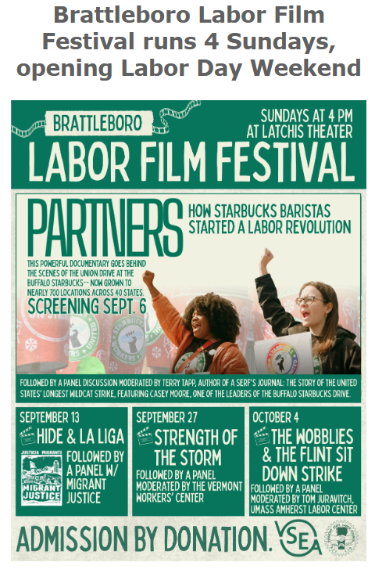
  - The Central Vermont Chapter has held inspirational art competitions where your art may be adopted by vote into the CVC Art Portfolio and receive a $50 prize, and your art might be placed onto flashy things!
- Want to get more involved?
  - Join a committee
    - Committee list, description, and current membership
    - Committee application
  - Join VSEA Council
    - Role of Council Members
    - Current Council Members
    - Council application (if there are vacancies. Can confirm vacancy with vsea@vsea.org)
- New Business
  - Open Forum
    - Comments/questions/concerns from members
- Old Business
- Adjournment
  - Next meeting will be held on [date here]

Notes
[Optional space for additional notes or comments]

